# Emerald-Academy-Quests

Emerald Academy Quests for Flow / Cadence development

**Chapter 1 - Day 1**

**What is a Blockchain ?**

It is a chain of nodes that connect to each other in a decentralized way. The nodes are called blocks and can store information in it, most of the time transactions. The blockchain doesn't belong to anyone and is viewable by anyone.

**What is a Smart Contract ?**

It is a "contract" that lives on the blockchain. It is used to communicate with the nodes and stores resources, transactions, scripts and more on the blocks. They are also used to immediately automate the execution of an agreement, so that all participants can be certain of the outcome, without any intermediary’s involvement.

**Difference between a Script and a Transaction?**

A script "looks" and reads information from the blockchain and is free, whereas a transaction costs GAS and actually changes the "state" within a smart contract on the blockchain.

**Chapter 1 - Day 2**

**What are the 5 Cadence Programming Language Pillars?**

1. Safety and Security

2. Clarity

3. Approachability

4. Developer Experience

5. Resource Oriented Programming

**In your opinion, even without knowing anything about the Blockchain or coding, why could the 5 Pillars be useful (you don't have to answer this for #5)?**

1- Because the smart contracts will normally contain valuable items, safety and security is CRUCIAL.

2- Learning a new language is so much easier when it is easy to understand.

3- It helps a lot when you feel familiar with so many concepts of Cadence that it almost feels like you already know it.

4- Debugging can be a nightmare if the errors are not clear and can put someone off of learning Cadence.

**Chapter 2 - Day 1**

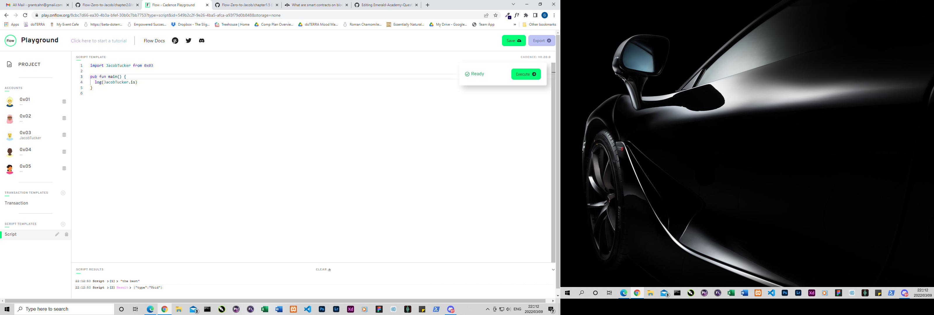

**Chapter 2 - Day 2**

**Explain why we wouldn't call changeGreeting in a script.**

A script can only “look at” or view the blockchain, it cannot change anything or “modify the state”

**What does the AuthAccount mean in the prepare phase of the transaction?**

It means the person “signing” the transaction and also the one paying for it. It also shows which account’s data we are accessing.

**What is the difference between the prepare phase and the execute phase in the transaction?**

The prepare phase is where you access the data on the AuthAccount’s account, whereas the execute phase is used to call functions and change data on the blockchain.

Add two new things inside your contract:

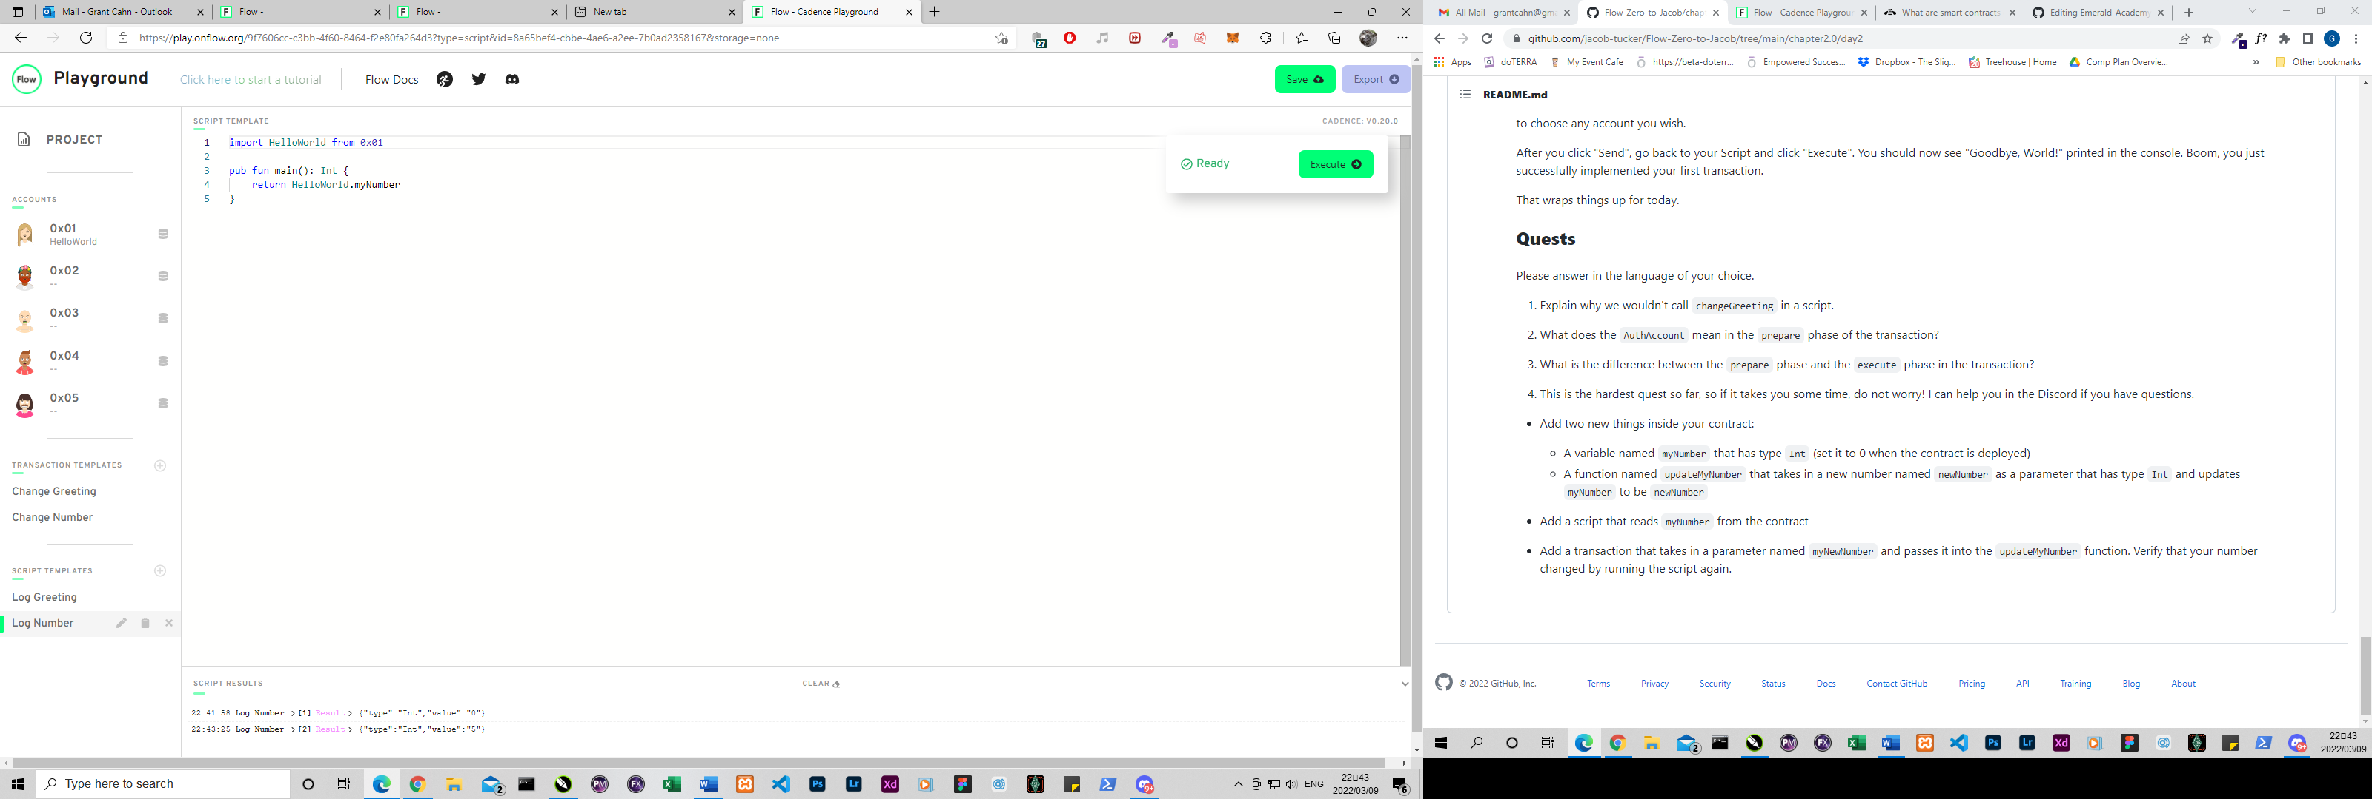

**Chapter 2 - Day 3**

1,2

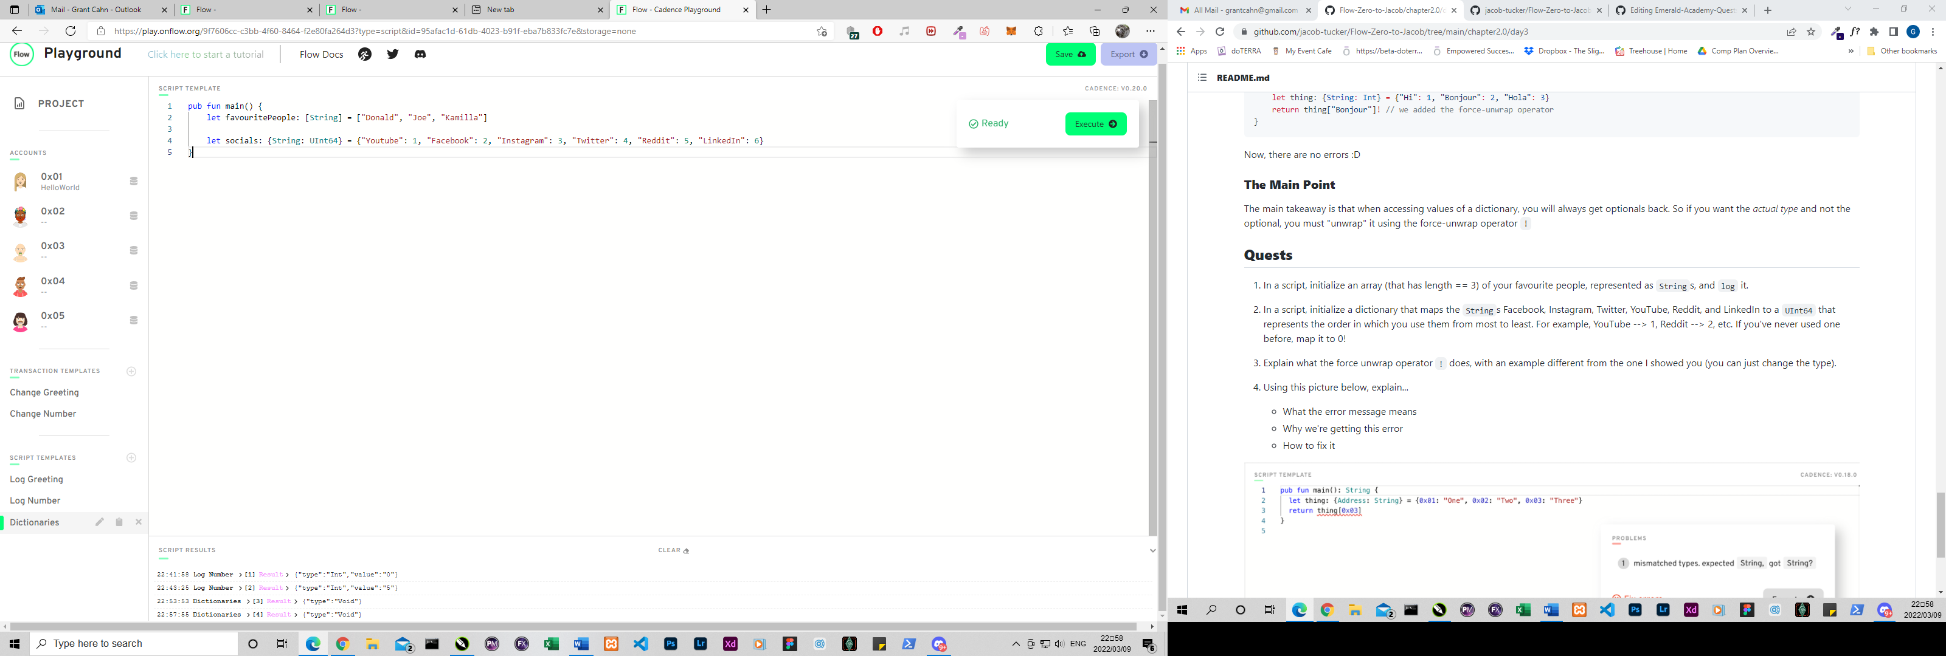

**3 Explain what the force unwrap operator ! does, with an example different from the one I showed you.**

The force unwrap operator takes an optional that was returned, and unwraps it to the type that we expect to get, or nil. If it’s nil, the program panics and aborts.

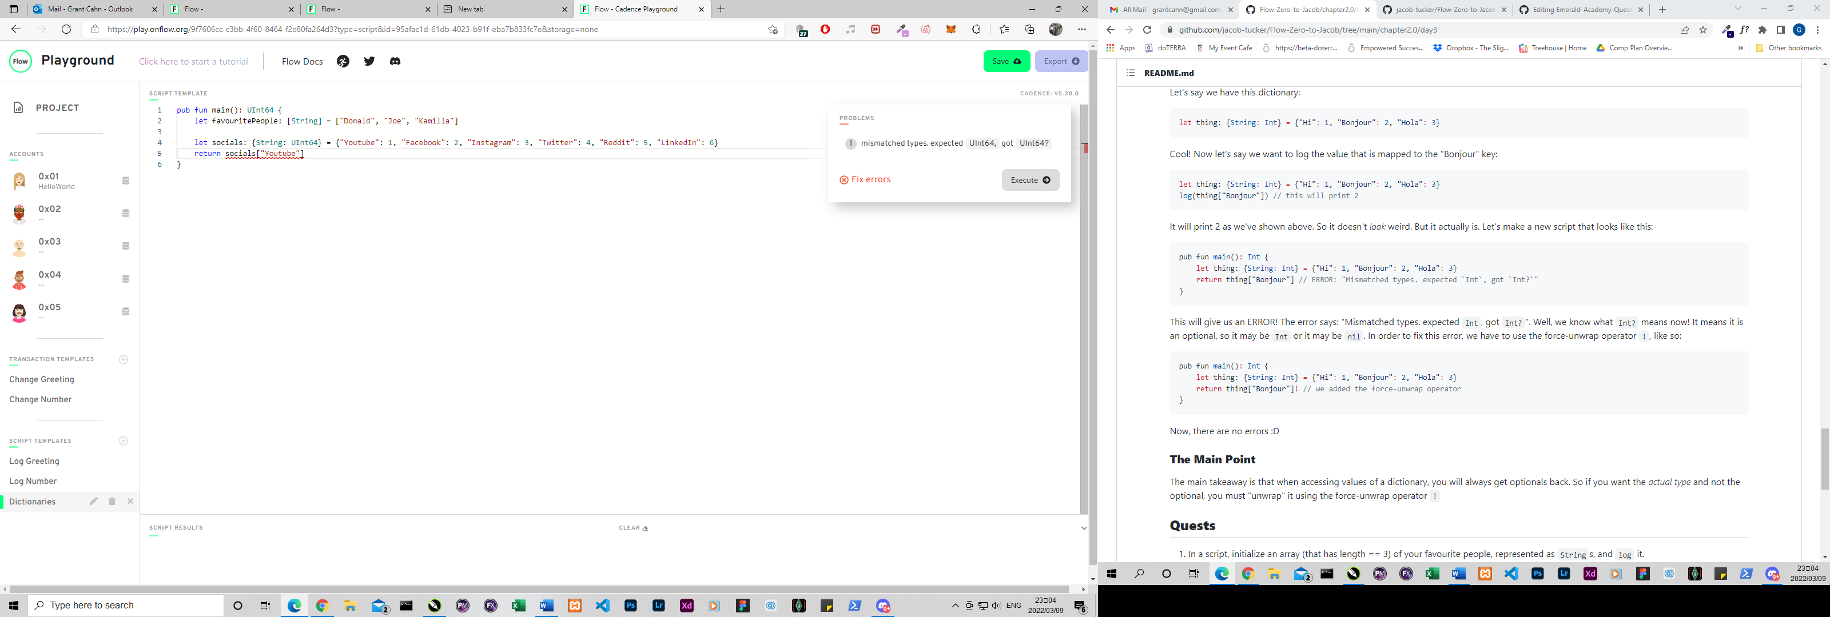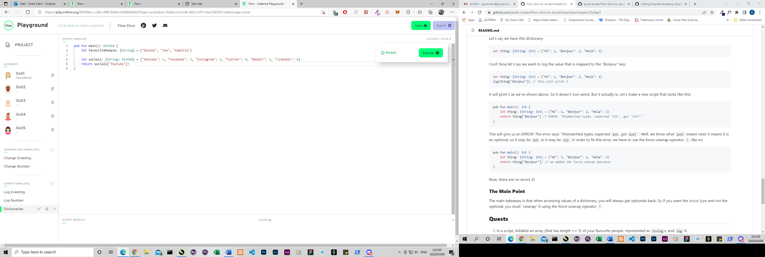

**4 What the error message means, why we are getting this error and how to fix it**

The error message means that there is a mismatch of types as “String” was expected but the function returned an optional “String?”. We mainly get this error when we return a value out of a dictionary. It is easily fixed by using the force unwrap operator after the brackets []!

**Chapter 2 - Day 4**

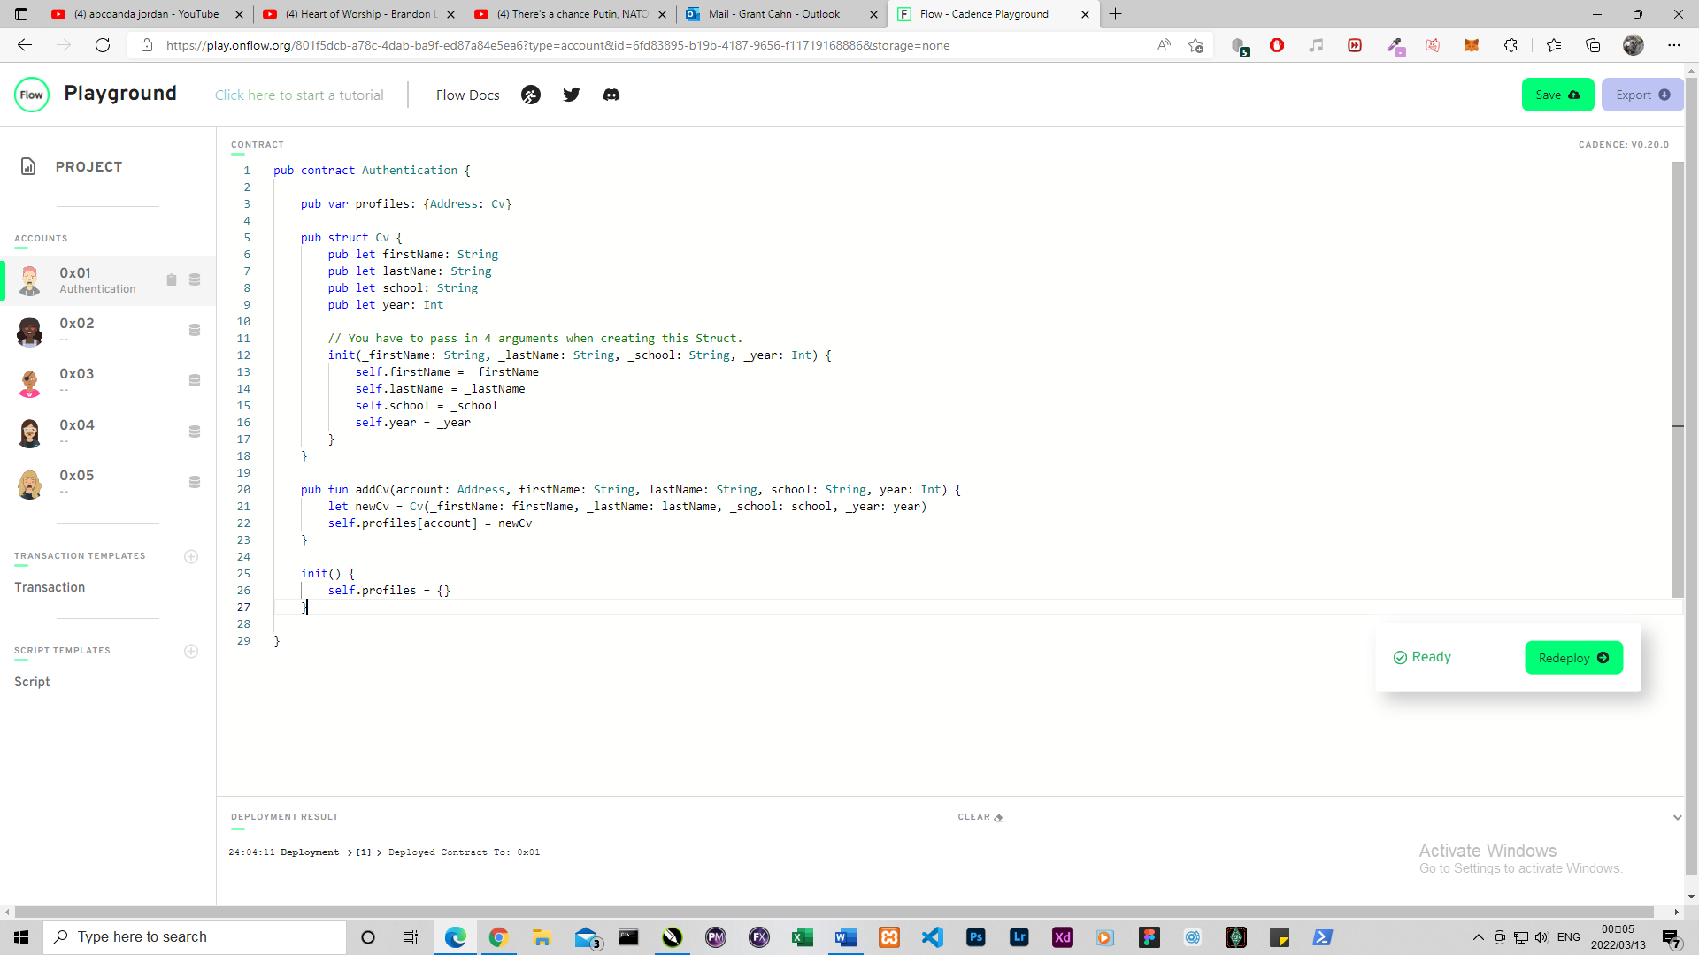

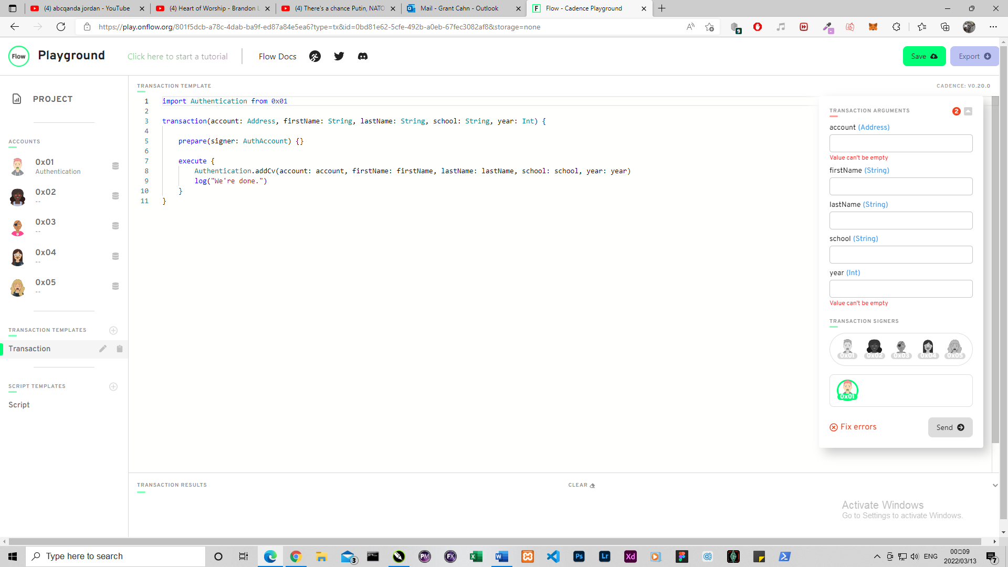

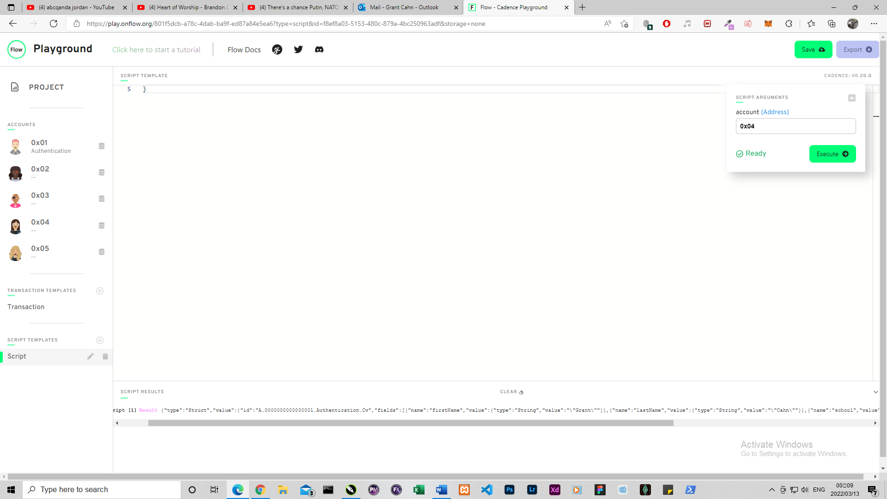

**Chapter 3 - Day 1**

1. In words, list 3 reasons why structs are different from resources.

Structs can be copied, overwritten and created outside of the contract whereas resources can’t.

1. Describe a situation where a resource might be better to use than a struct.

When you want to make unique things like NFT’s, which can be worth a lot of money, it is useful to use something that can’t be easily lost or copied.

1. What is the keyword to make a new resource?

The keyword “create” is used to create a new resource.

1. Can a resource be created in a script or transaction (assuming there isn't a public function to create one)?

No.

1. What is the type of the resource below?

Jacob.

1. Let's play the "I Spy" game from when we were kids. I Spy 4 things wrong with this code. Please fix them.

pub contract Test {

// Hint: There's nothing wrong here ;)

pub resource Jacob {

pub let rocks: Bool

init() {

self.rocks = true

}

}

pub fun createJacob(): Jacob { // there is 1 here

let myJacob = Jacob() // there are 2 here

return myJacob // there is 1 here

}

}

pub contract Test {

pub resource Jacob {

pub let rocks: Bool

init() {

self.rocks = true

}

}

pub fun createJacob(): @Jacob {

let myJacob <- create Jacob()

return <- myJacob

}

}

**Chapter 3 - Day 2**

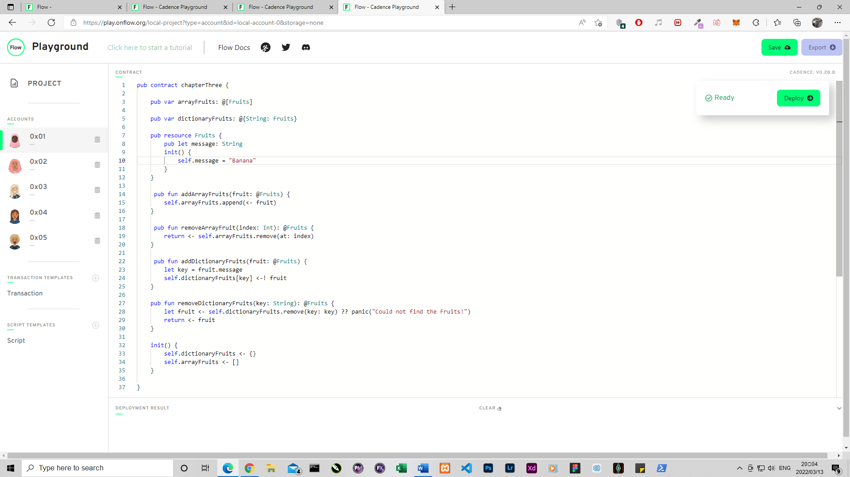

**Chapter 3 - Day 3**

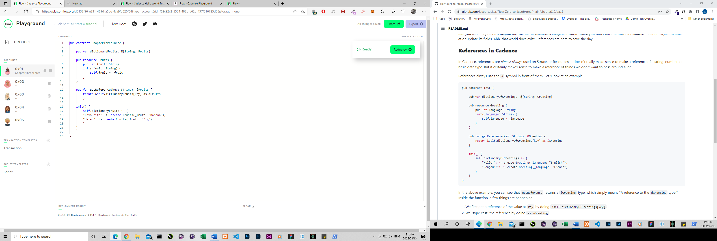

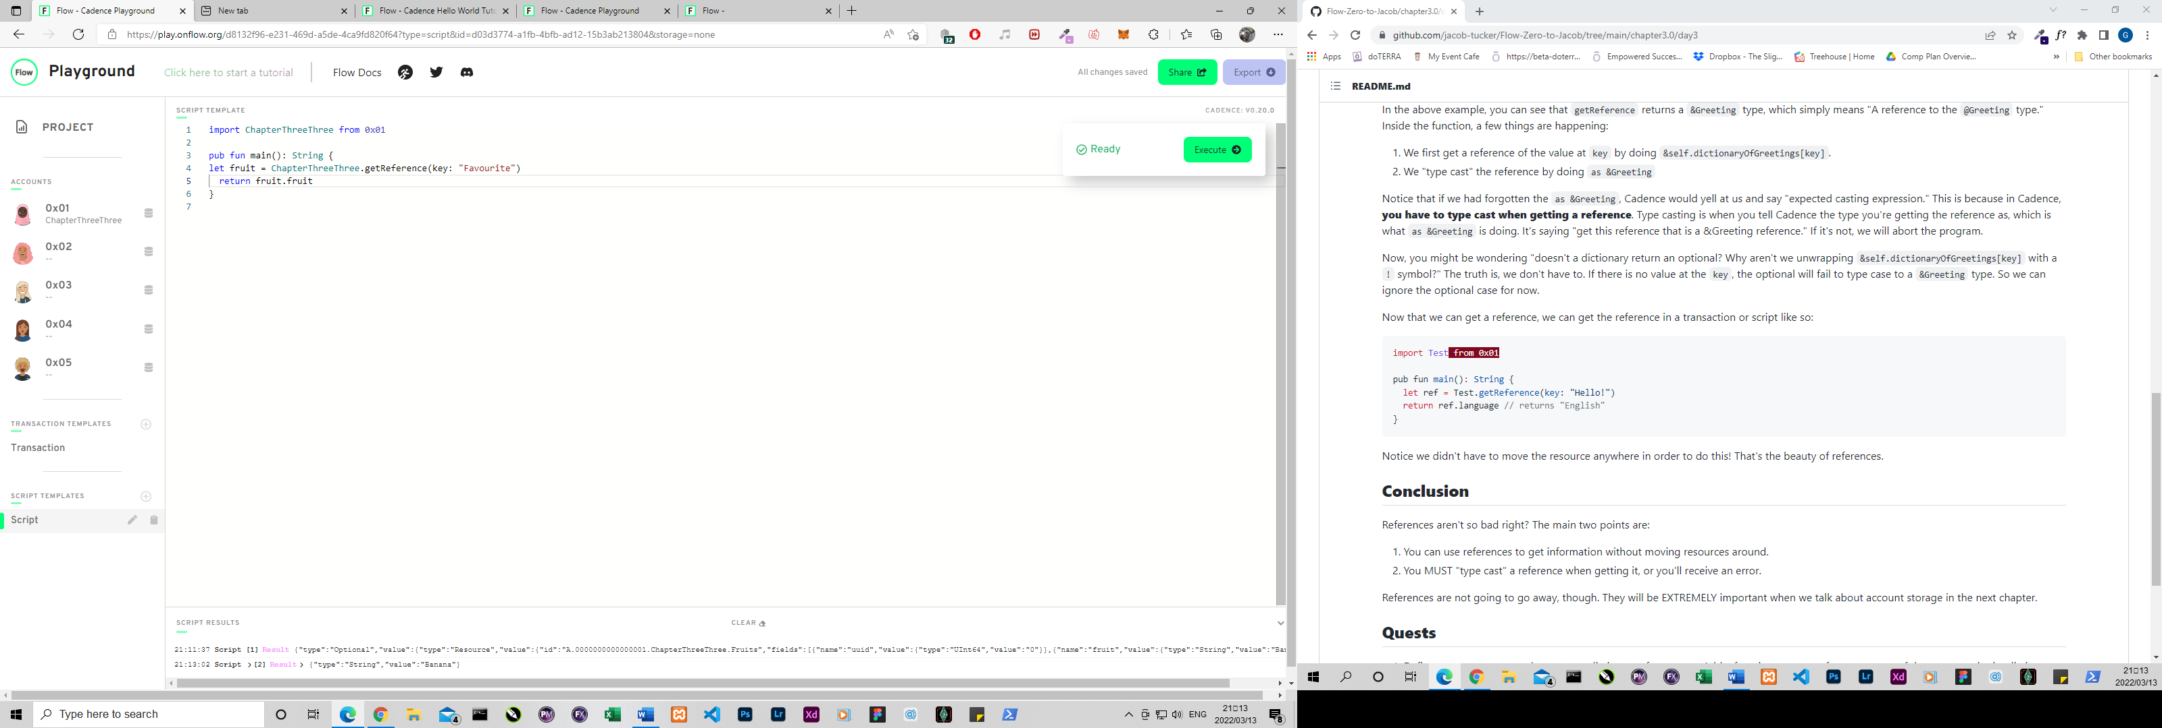

3 Explain, in your own words, why references can be useful in Cadence.

References can be very useful because we don’t want to move resources around a lot, so we can use references instead to run scripts or transactions with information about the resource without handling the actual resource.

**Chapter 3 - Day 4**

1. Explain, in your own words, the 2 things resource interfaces can be used for (we went over both in today's content)

Resource interfaces are almost like the “parents” of a resource. They set the rules of which variables and functions a resource MUST have, and also which variables or functions your friends are “allowed to play with” 😊 (which are exposed to the public)

2

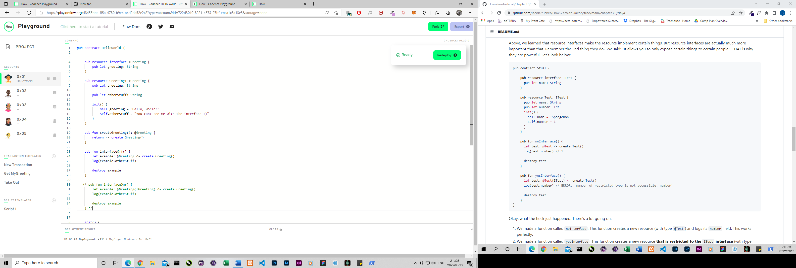

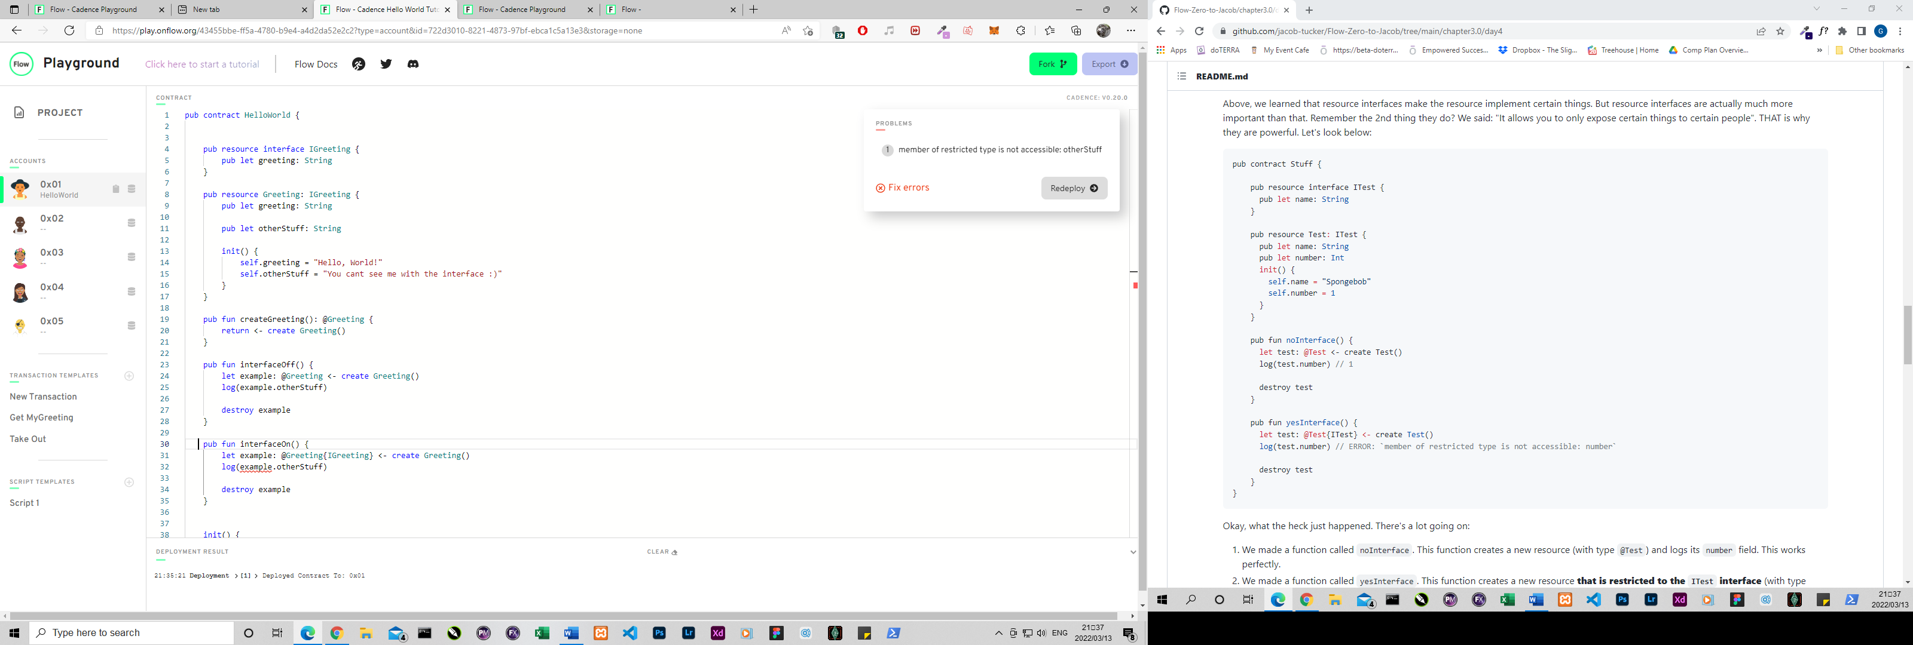

1. How would we fix this code?

pub contract Stuff {

pub struct interface ITest {

pub var greeting: String

pub var favouriteFruit: String

}

// ERROR:

// `structure Stuff.Test does not conform

// to structure interface Stuff.ITest`

pub struct Test: ITest {

pub var greeting: String

pub var favouriteFruit: String

pub fun changeGreeting(newGreeting: String): String {

self.greeting = newGreeting

return self.greeting // returns the new greeting

}

init() {

self.greeting = "Hello!"

}

}

pub fun fixThis() {

let test: @Test{ITest} <- create Test()

let newGreeting = test.changeGreeting(newGreeting: "Bonjour!") // ERROR HERE: `member of restricted type is not accessible: changeGreeting`

log(newGreeting)

}

}

We can either add the function changeGreeting to the interface or we can remove the implementation of the interface.

**Chapter 3 - Day 5**

1a – Read from everywhere and written from everywhere

b- Readable and writable

c- Readable and writable

d- Readable and writable

2a – Read from everywhere and written from everywhere

b- Readable but not writable

c- Readable but not writable

d- Not readable or writable

3 a – Read from everywhere and written from everywhere

b- Readable but not writable

c- Readable but not writable

d- Not readable or writable

4 a – Read from everywhere and written from everywhere

b- Readable but not writable

c- Not readable or writable

d- Not readable or writable

publicFunc – Callable form anywhere

contractFunc – Callable from within SomeContract

privateFunc – Callable within SomeStruct

**Chapter 4 - Day 1**

1. Explain what lives inside of an account.

An account has two “compartments” – One is the contract code and the other is the account storage.

1. What is the difference between the /storage/, /public/, and /private/ paths?

The biggest difference is who has access.

/storage/ - Only the owner

/public/ - Everyone

/private/ - The owner and people that the owner gives access to

1. What does .save() do? What does .load() do? What does .borrow() do?

.save – saves a resource to /storage/

.load – Takes out a resource out of storage

.borrow – Borrows a reference to the resource (resource stays in storage)

1. Explain why we couldn't save something to our account storage inside of a script.

Because a script cannot modify or change the state of the contract.

1. Explain why I couldn't save something to your account.

Because only the owner of the account has access to their own /storage/

1. Define a contract that returns a resource that has at least 1 field in it. Then, write 2 transactions:
   1. A transaction that first saves the resource to account storage, then loads it out of account storage, logs a field inside the resource, and destroys it.
   2. A transaction that first saves the resource to account storage, then borrows a reference to it, and logs a field inside the resource.

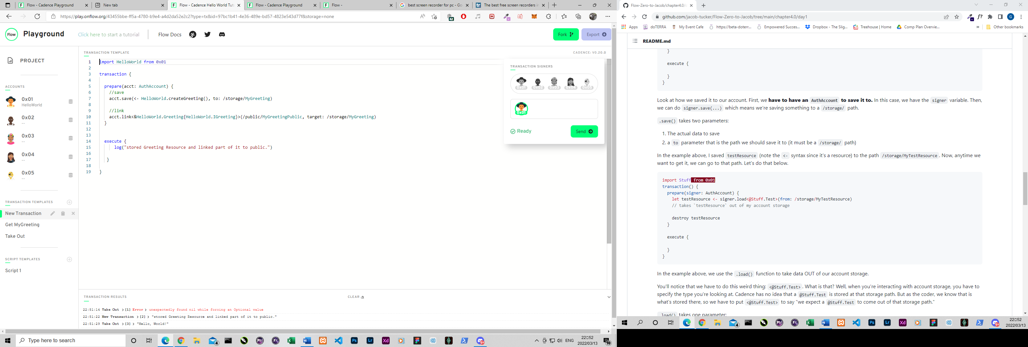

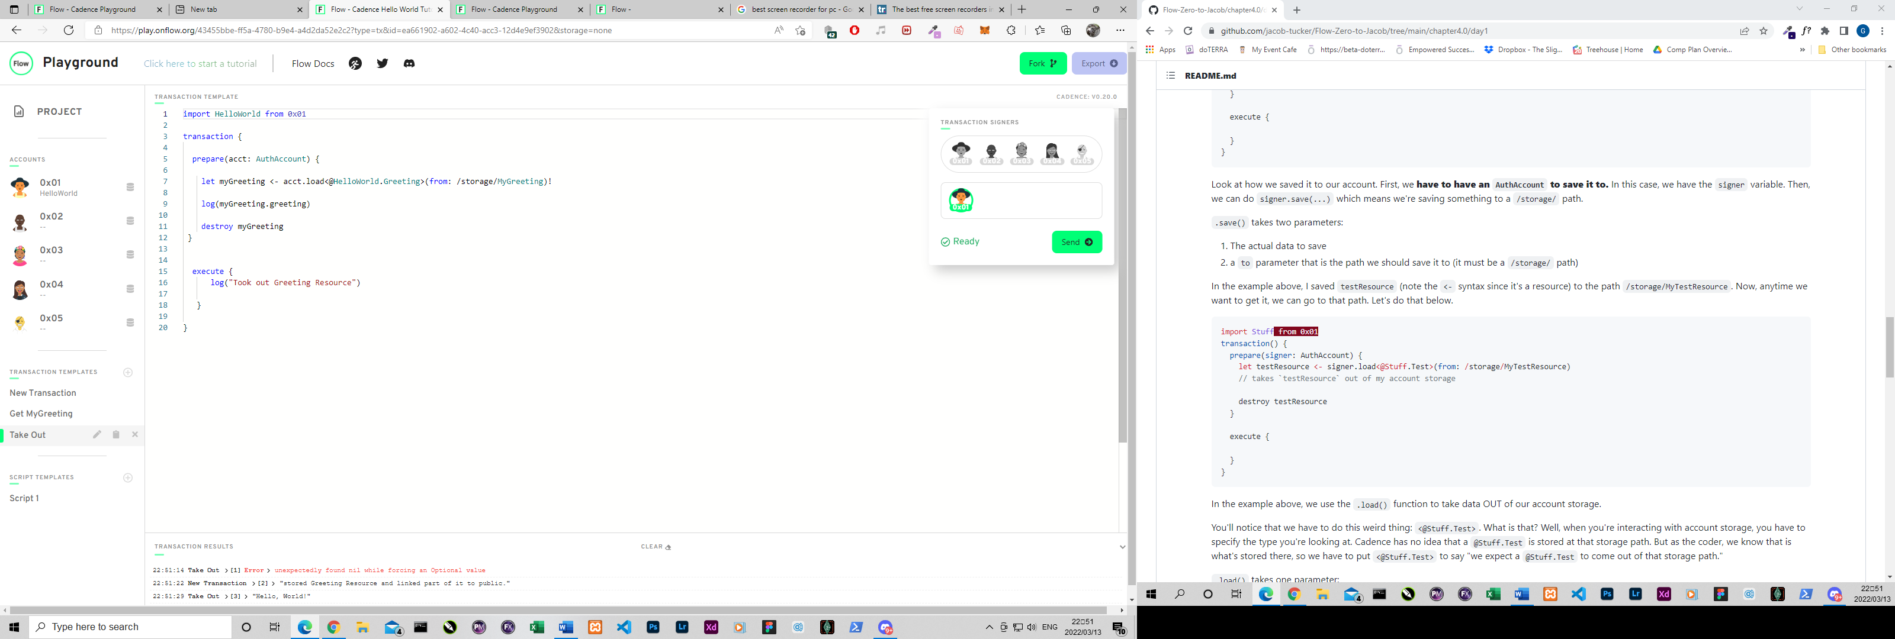

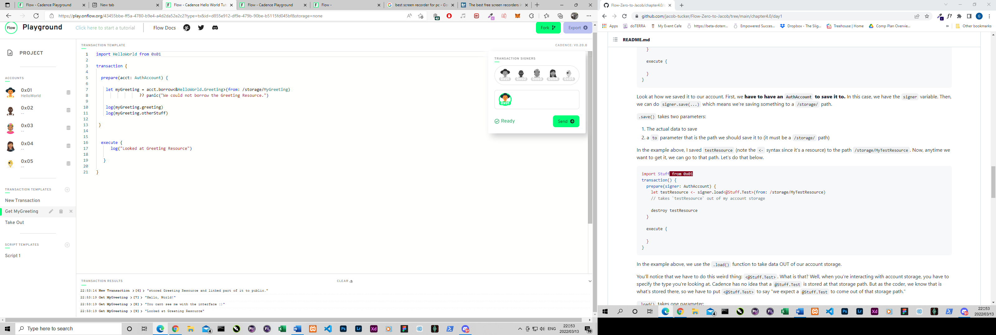

**Chapter 4 - Day 2**

1. What does .link() do?

.link – creates a capability in the /public/ or /private/ paths that someone can use to get a reference to a resource that is in storage.

1. In your own words (no code), explain how we can use resource interfaces to only expose certain things to the /public/ path.

A resource interface limits the variables or functions within a resource that is exposed to the public. This way we can keep functions like destroy() or withdraw() hidden form the public whilst still having the name or id fields be visible to the public.

1. Deploy a contract that contains a resource that implements a resource interface. Then, do the following:
   1. In a transaction, save the resource to storage and link it to the public with the restrictive interface.

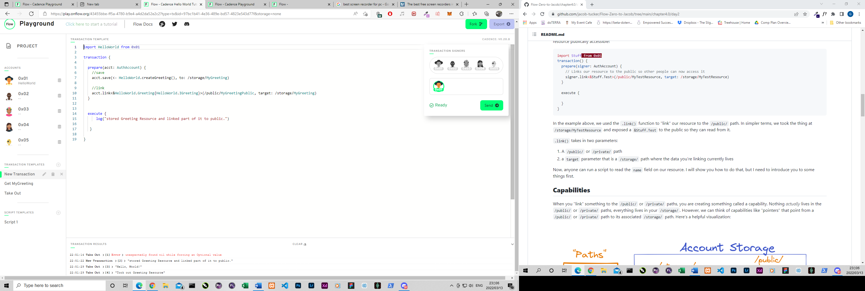

* 1. Run a script that tries to access a non-exposed field in the resource interface, and see the error pop up.

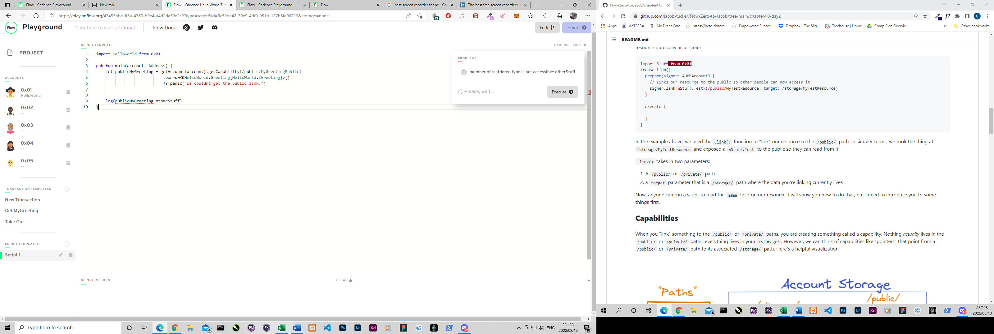

* 1. Run the script and access something you CAN read from. Return it from the script.

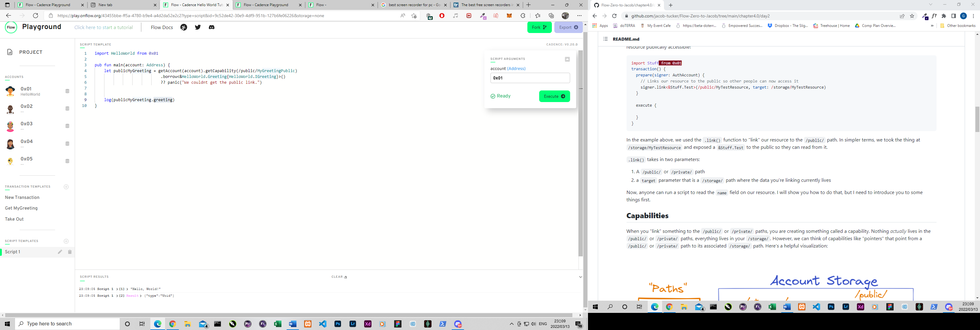

**Chapter 4 - Day 3**

1. What do you have to do if you have resources "nested" inside of another resource? ("Nested resources")

You have to define a destroy function to be able to destroy nested resources.

1. Brainstorm some extra things we may want to add to this contract. Think about what might be problematic with this contract and how we could fix it.

We would definitely need an Admin account that will be in charge of the minting of new NFT’s.

We need to make a reference to the Collections NFT’s which contains the information that we want to be readable by the public.

Idea [#1](https://github.com/jacob-tucker/Flow-Zero-to-Jacob/pull/1): Do we really want everyone to be able to mint an NFT? (insert thinking emoji here).

Idea [#2](https://github.com/jacob-tucker/Flow-Zero-to-Jacob/issues/2): If we want to read information about our NFTs inside our Collection, right now we have to take it out of the Collection to do so. Is this good?

**Chapter 4 - Day 4**

pub contract CryptoPoops {

pub var totalSupply: UInt64

// This is an NFT resource that contains a name,

// favouriteFood, and luckyNumber

pub resource NFT {

pub let id: UInt64

pub let name: String

pub let favouriteFood: String

pub let luckyNumber: Int

init(_name: String, _favouriteFood: String, _luckyNumber: Int) {

self.id = self.uuid

self.name = _name

self.favouriteFood = _favouriteFood

self.luckyNumber = _luckyNumber

}

}

// This is a resource interface that restricts which of the Collection resource’s variables //and functions are visible and callable from the public.

pub resource interface CollectionPublic {

pub fun deposit(token: @NFT)

pub fun getIDs(): [UInt64]

pub fun borrowNFT(id: UInt64): &NFT

}

// This is the Collection resource which we use to store multiple NFT resources in one storage //location

pub resource Collection: CollectionPublic {

pub var ownedNFTs: @{UInt64: NFT}

//This is the deposit function that is callable by anyone (because more NFT’s is MORE)

pub fun deposit(token: @NFT) {

self.ownedNFTs[token.id] <-! token

}

// This is the withdraw function which is limited to only the AuthAccount

pub fun withdraw(withdrawID: UInt64): @NFT {

let nft <- self.ownedNFTs.remove(key: withdrawID)

?? panic("This NFT does not exist in this Collection.")

return <- nft

}

// This function logs all the NFT id’s

pub fun getIDs(): [UInt64] {

return self.ownedNFTs.keys

}

//This function allows the public to read the NFT information without having to remove it from //the Collection

pub fun borrowNFT(id: UInt64): &NFT {

return &self.ownedNFTs[id] as &NFT

}

init() {

self.ownedNFTs <- {}

}

// This is the destroy function needed when you have nested resources

destroy() {

destroy self.ownedNFTs

}

}

// This creates an empty Collection resource in an account

pub fun createEmptyCollection(): @Collection {

return <- create Collection()

}

//This is the Minter resource which is used by the contract owner to mint new NFT’s

pub resource Minter {

// This function creates new NFT resources

pub fun createNFT(name: String, favouriteFood: String, luckyNumber: Int): @NFT {

return <- create NFT(_name: name, _favouriteFood: favouriteFood, _luckyNumber: luckyNumber)

}

// This function creates a new Minter resource

pub fun createMinter(): @Minter {

return <- create Minter()

}

}

init() {

self.totalSupply = 0

self.account.save(<- create Minter(), to: /storage/Minter)

}

}

**Chapter 5 - Day 1**

1. Describe what an event is, and why it might be useful to a client.

An event is a message that is sent to the outside world that something has happened. It can describe when a certain function was run and can also contain details regarding the transaction that might be useful to know such as the uuid etc.

1. Deploy a contract with an event in it, and emit the event somewhere else in the contract indicating that it happened.

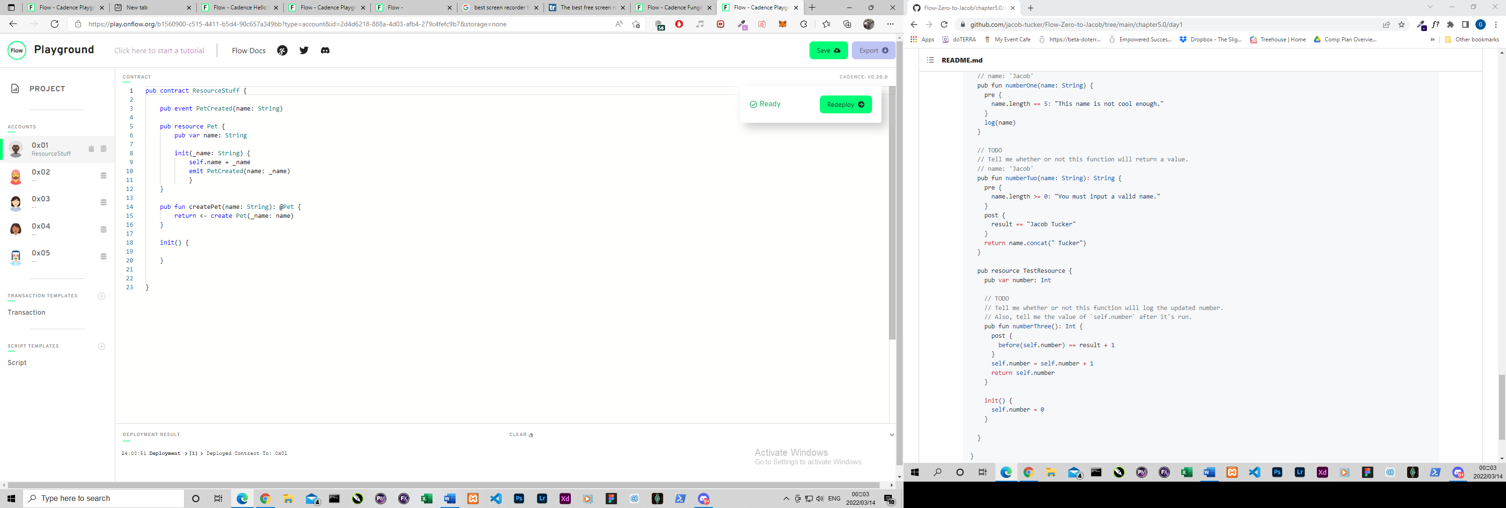

1. Using the contract in step 2), add some pre conditions and post conditions to your contract to get used to writing them out.

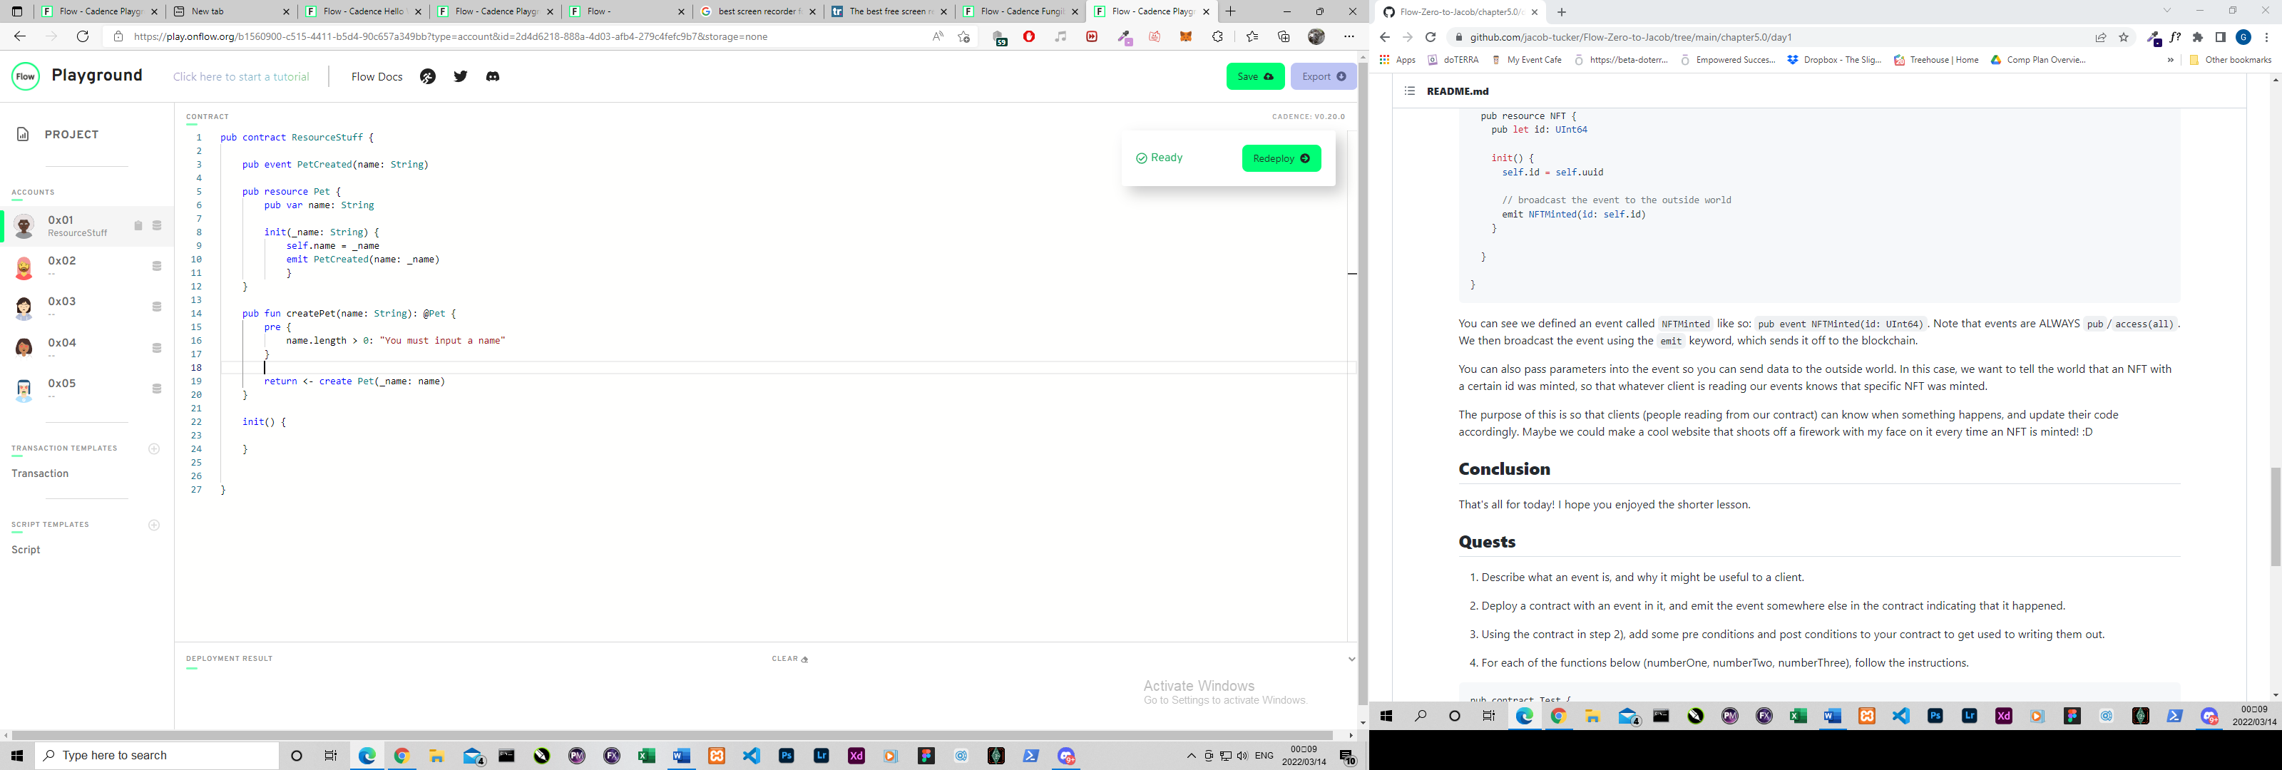

1. For each of the functions below (numberOne, numberTwo, numberThree), follow the instructions.

NumberOne – Yes it will log the name

NumberTwo – Yes it will return the name

NumberThree – No. self.number will be = 0

**Chapter 5 - Day 2**

1. Explain why standards can be beneficial to the Flow ecosystem.

Standards make it easier and safer for contracts from different developers to be used by the same people. It makes the contracts work and behave the same way across the board. This also makes it easier for developers to work together on projects.

1. What is YOUR favourite food?

“Ribs and Garlic Bread 😉”

1. Please fix this code (Hint: There are two things wrong):

The contract interface:

pub contract interface ITest {

pub var number: Int

pub fun updateNumber(newNumber: Int) {

pre {

newNumber >= 0: "We don't like negative numbers for some reason. We're mean."

}

post {

self.number == newNumber: "Didn't update the number to be the new number."

}

}

pub resource interface IStuff {

pub var favouriteActivity: String

}

pub resource Stuff: IStuff {

pub var favouriteActivity: String

}

}

The implementing contract:

pub contract Test: Itest {

pub var number: Int

pub fun updateNumber(newNumber: Int) {

self.number = 5

}

pub resource interface IStuff {

pub var favouriteActivity: String Not Needed

}

pub resource Stuff: ITest.IStuff {

pub var favouriteActivity: String

init() {

self.favouriteActivity = "Playing League of Legends."

}

}

init() {

self.number = 0

}

}

**Chapter 5 - Day 3**

1. What does "force casting" with as! do? Why is it useful in our Collection?

It “downcasts” the type to a more specific type to make sure we are using the correct type of resource. Because all NFT contracts conform to the standard, we want to make sure that we work with our specific contract’s NFT type.

1. What does auth do? When do we use it?

We use auth when we need to downcast a reference to a specific resource reference that we want to use.

3.

